### 

### Semester One Examination, 2023

### Question/Answer booklet

# 12 SPECIALIST MATHEMATICS

## Section One:

## Calculator-free

|  |
| --- |
|  |

Your Name

Your Teacher’s Name

## Time allowed for this section

Reading time before commencing work: five minutes

Working time: fifty minutes

## Materials required/recommended for this section

***To be provided by the supervisor***

This Question/Answer booklet

Formula sheet

***To be provided by the candidate***

Standard items: pens (blue/black preferred), pencils (including coloured), sharpener, correction fluid/tape, eraser, ruler, highlighters

Special items: nil

## Important note to candidates

No other items may be taken into the examination room. It is **your** responsibility to ensure that you do not have any unauthorised material. If you have any unauthorised material with you, hand it to the supervisor **before** reading any further.

|  |  |  |  |  |  |
| --- | --- | --- | --- | --- | --- |
| Question | Mark | Max | Question | Mark | Max |
| 1 |  | 8 | 5 |  | 10 |
| 2 |  | 8 | 6 |  | 9 |
| 3 |  | 8 |
| 4 |  | 7 |

**Structure of this paper**

|  |  |  |  |  |  |
| --- | --- | --- | --- | --- | --- |
| Section | Number of questions available | Number of questions to be answered | Working time (minutes) | Marks available | Percentage of examination |
| Section One:  Calculator-free | 6 | 6 | 50 | 50 | 34 |
| Section Two:  Calculator-assumed | 12 | 12 | 100 | 97 | 66 |
|  |  |  |  | **Total** | 100 |

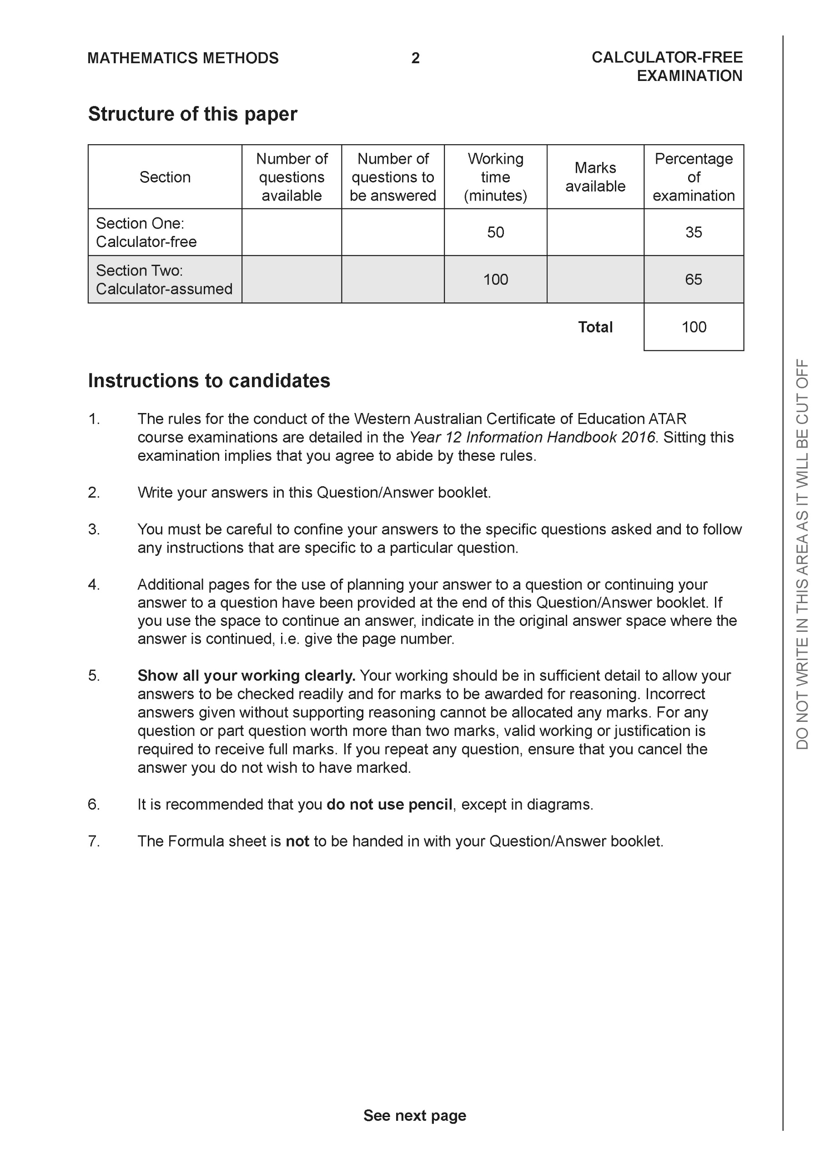

**Section One: Calculator-free (50 Marks)**

This section has **seven (7)** questions. Answer **all** questions. Write your answers in the spaces provided.

Spare pages are included at the end of this booklet. They can be used for planning your responses and/or as additional space if required to continue an answer.

● Planning: If you use the spare pages for planning, indicate this clearly at the top of the page.

● Continuing an answer: If you need to use the space to continue an answer, indicate in the original answer space where the answer is continued, i.e. give the page number. Fill in the number of the question that you are continuing to answer at the top of the page.

Working time: 50 minutes.

**Question 1 (8 marks)**

Consider the functions  and .

1. Determine the natural domain and range of . (2 marks)
2. Does  exist over the natural domain of ? Explain. (3 marks)
3. Determine  and its natural domain. (3 marks)

**Question 2 (8 marks)**

Consider the function  which is graphed below.

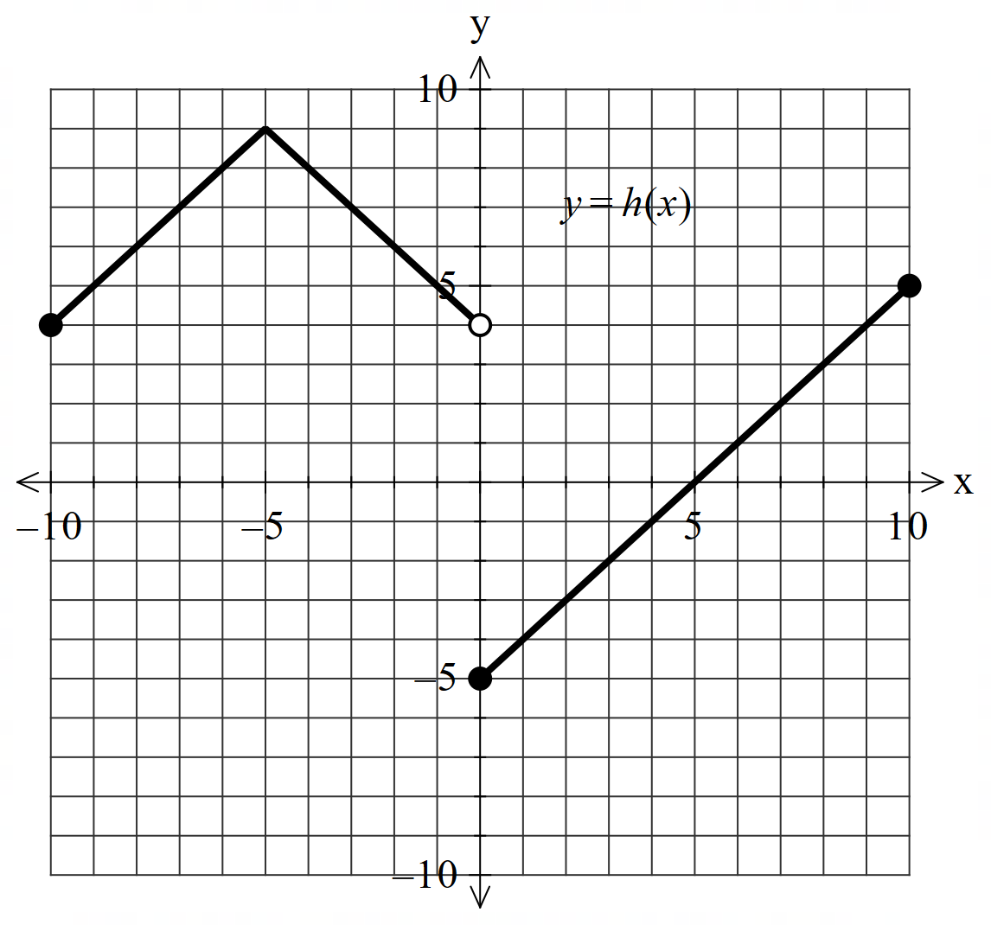

1. Solve for . (2 marks)
2. Sketch  on the axes below. (3 marks)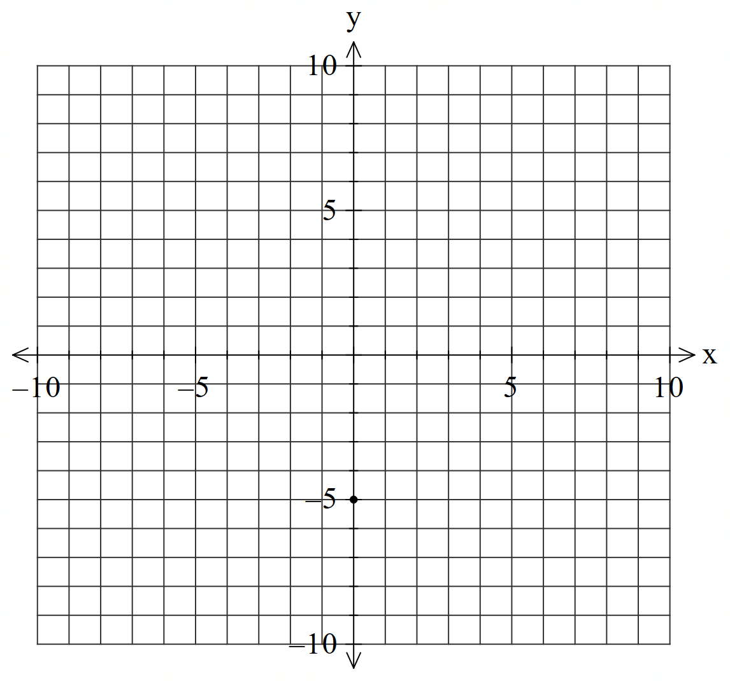

**Q2 continued-**

1. Sketch  on the axes below. (3 marks)

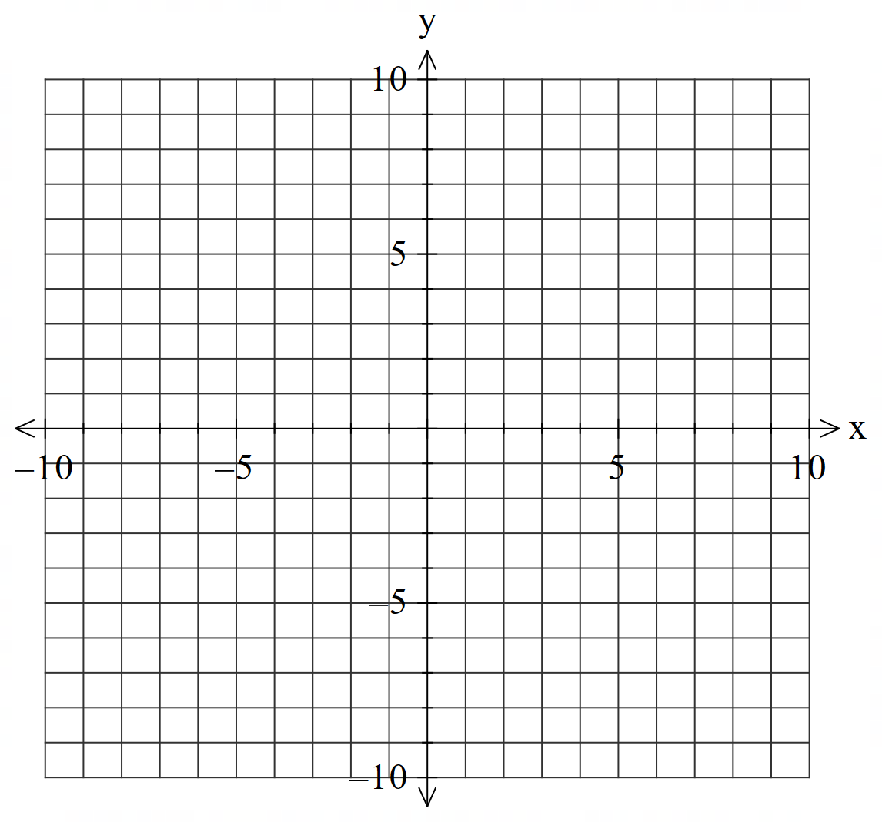

**Question 3 (8 marks)**

Consider the following planes:



1. Show that none of these planes are parallel. (2 marks)

Q3 continued-

1. Solve the system of simultaneous equations. (3 marks)
2. Consider the system of equations below with  being constants.

(3 marks)



Determine all possible values of such that there are:

1. No solutions.
2. Infinite solutions.
3. A unique solution.

**Question 4 (7 marks)**

Consider the three complex numbers plotted below in the Argand diagram.

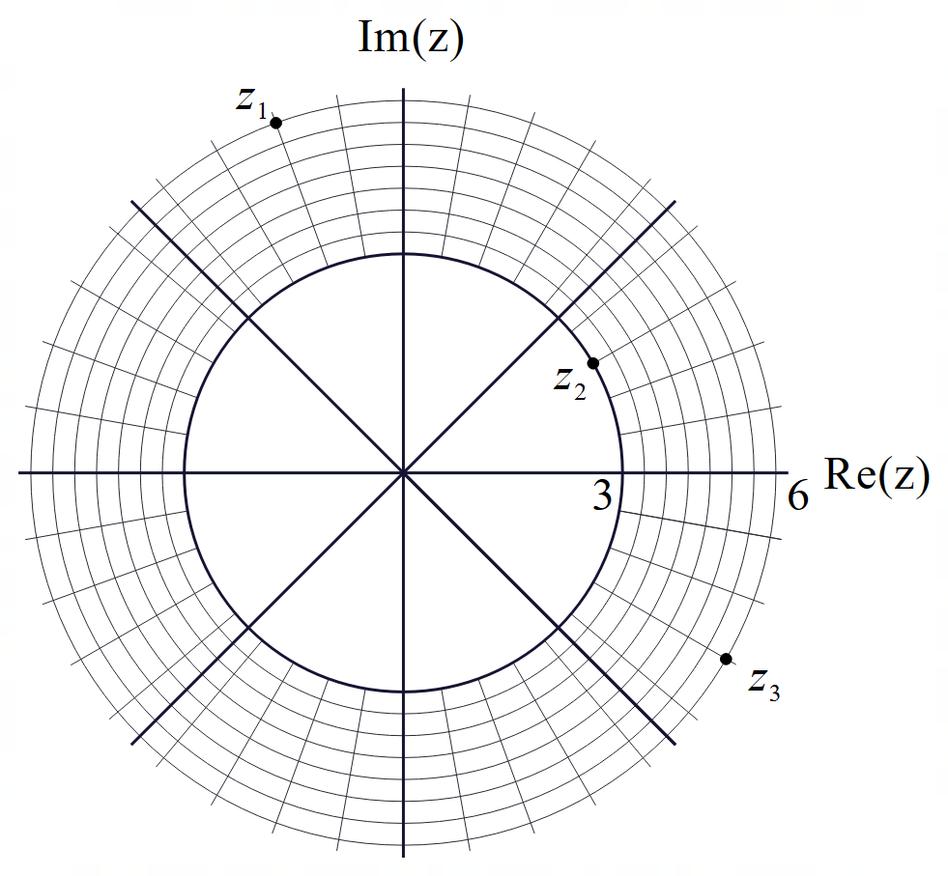

1. Determine the complex number  in exact cartesian form. (2 marks)
2. Plot the complex number  on the axes above. (2 marks)
3. State the modulus and argument of . (3 marks)

**Question 5 (10 marks)**

Consider the function  which is graphed below.

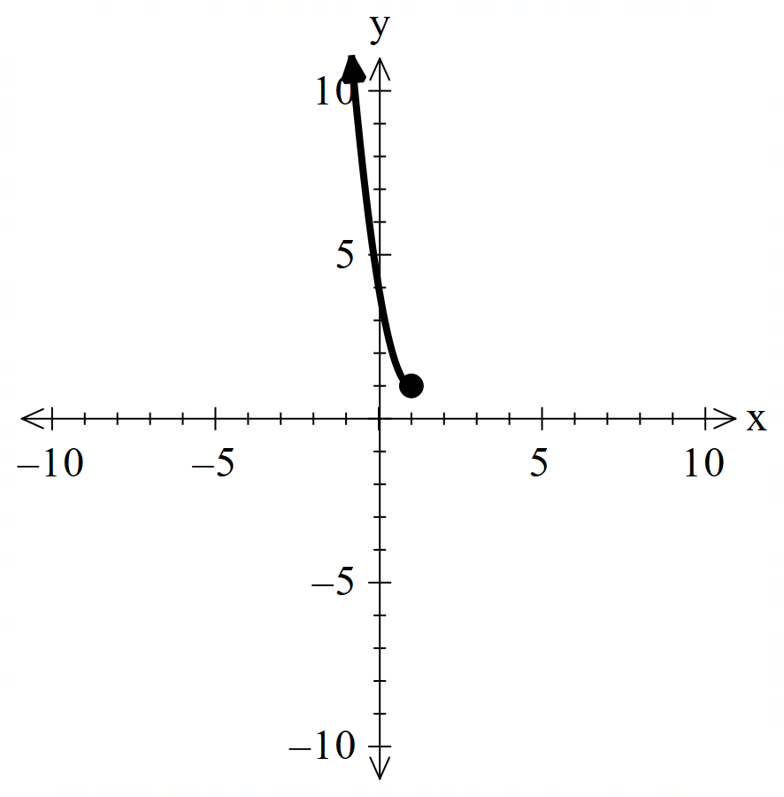

1. On the axes above, plot . (2 marks)
2. Determine the rule for  and state its domain. (3 marks)

Consider the function  where  is a positive constant.

1. Does  have an inverse function? Explain. (2 marks)
2. Determine the x values in terms of  for where . (3 marks)

**Question 6 (9 marks)**

The Argand diagram below shows a right-angled triangle , with semicircle centred at .

<EFOFEX>

id:fxd{464e33fe-6a27-4b09-9973-827da3eac656}


FXData:


</EFOFEX>

(a) Given represents the complex number , determine the complex number  
representing . (1 mark)

(b) State the locus of points that define semicircle . (3 marks)

The rays and form angles of with the positive direction of the real axis.

Let be the complex number , and be the complex number .

(c) Determine, in polar form, . (3 marks)

(d) Explain why . (2 marks)

**End of section one**

**Working out space.**

Working out space.